New Functionality added to IsisMarc (IsisMarc 1.542)

- Search records inside IsisMarc.

From IsisMarc 1.53 adds the posibility to search inside the active database and after doing double click over a result of the search, to go to the record. The interface is similar to WinIsis’s expert search. The way to access this record navigator is through the Menu Option:

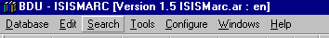

Or through the icon in the toolbar:

This option could be accesed in any moment when a database window is open. The main window looks like that:
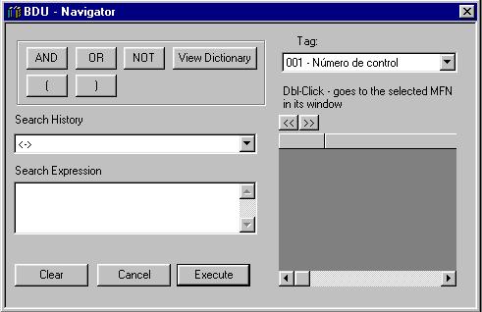

The principal areas in this window are:

- Search expression. This area is used for inserting the text that the user is looking for.
- Search History. Remembers all the searches that the user did in the present session. Could be used for inserting previous searches in the search expression.
- Buttons: Simply add the signs that corresponds to the desired operator. Also invokes the dictionary.
- Tag choice. Using this option the user could choice which field will be showed joint to the MFN of the result in the result list. It will NOT add a condition in the search, it’s use is related to define which field present in the result list. However if you want to make a search for a particular FST line you could do it using regular Isis Search expression (as Medicine$/(2) for example).
- Result List. This section presents the MFN and the selected record field as result for the search expression (see before).

Dictionary.

The Dictionary window is invoked by the Dictionary Button inside search window. The Dictionary window looks as follow:

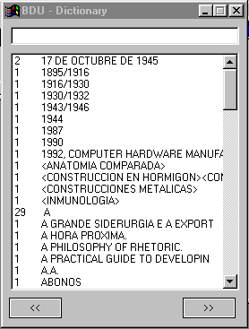
The user could select one or more terms from the list. Could insert characters in the top line and automatically the dictionary window will present the dictionary terms that matches with the terms. Exactly as WinIsis. The user could use the bottom navigator buttons for navigating inside dictionary.

When the user wants to search records based in dictionary terms, simply double clicks the term, and it will be transported inside Search Expression from Search Window.

Attention: If search expression is not empty automatically will be added a plus (+) sign between the actual content and the term selected.

The Dictionary window is closed automatically when search window is closed.

Navigating inside Records

When the user puts an expression inside Search Expression, could press Enter Key or Execute Button and a list of results is showed:

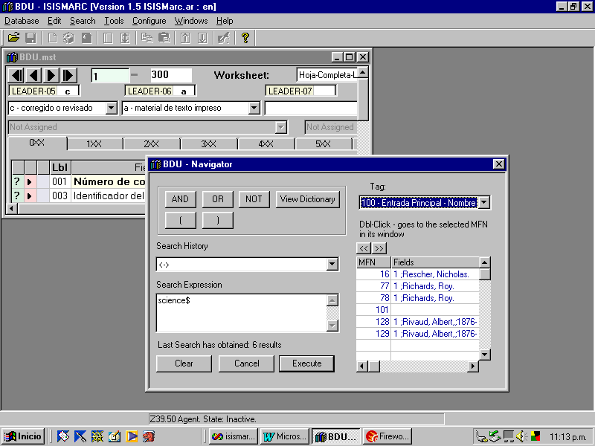
In the previous example the user has insert the term science$ and IsisMarc shows that 6 records contains that term (In the above example we’ve chosen to present tag 100 joint to MFN).

The easiest way to go to some of the result records is simply to double click in the list. This action will order to the database window to go to the selected record. Let’s see:

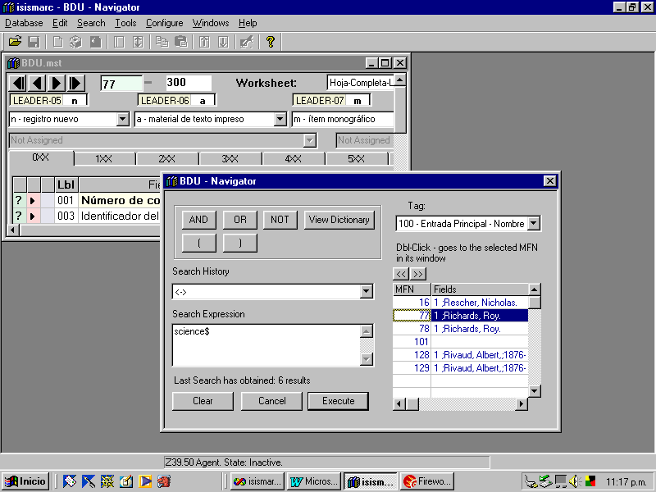
The user clicks over a record and the database window, goes to the selected record
For editing the record, the user simply must click over the database window, and start the editing task. The user could maximize the database window, but whenever the search function is invoked the database window will be restored to the original size.

- Adding MARC records to a database. Importing Marc Records.

IsisMarc 1.54 could import MARC (ISO2709) records directly.
All the imported records will go to an intermediate internal database and the user could select it, present it and copy to a common database.

All the import options added must work over a database window, this means that a database must be opened to access this functionality.

IsisMarc 1.54 could admit to import records pasting MARC content inside import window, or defining the name of the file that contains MARC records. IsisMarc will determine automatically if the content represents a MARC record or the name of a file.

The way to access this functions is through the menu option:

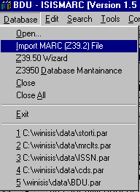
This option will present a window that allow the user to select the file or pasting the record, a progress bar that indicates the state of the convertion, and the record list that will present the imported records to the moment.

If the user wants to process a file could select the file chooser pressing the ellipsis button (...) and a Dialog Box will be shown. This dialog allows to the user to indicate the file to import. After a valid file is chosen the Button Process It! Will be enabled. The user must click it for starting the import process. Before doing so, the user could select if wants to apply diacritics over the imported record and if wants to apply autonumbering for 001 field when the records are inserted into the database.

If autonumbering is checked, and if isismarc2.cip’s AUTONUMBER parameter is redirected to a lock file, the Insert Record operation will replace 001 Marc field for the apropiate number used commonly for this database. The same applies to AUTOPREFIX.

Copy Cataloguing.

The first step consist in obtaining the record. For demostrating purposes we’ve choose Library Of Congress for downloading individual records.

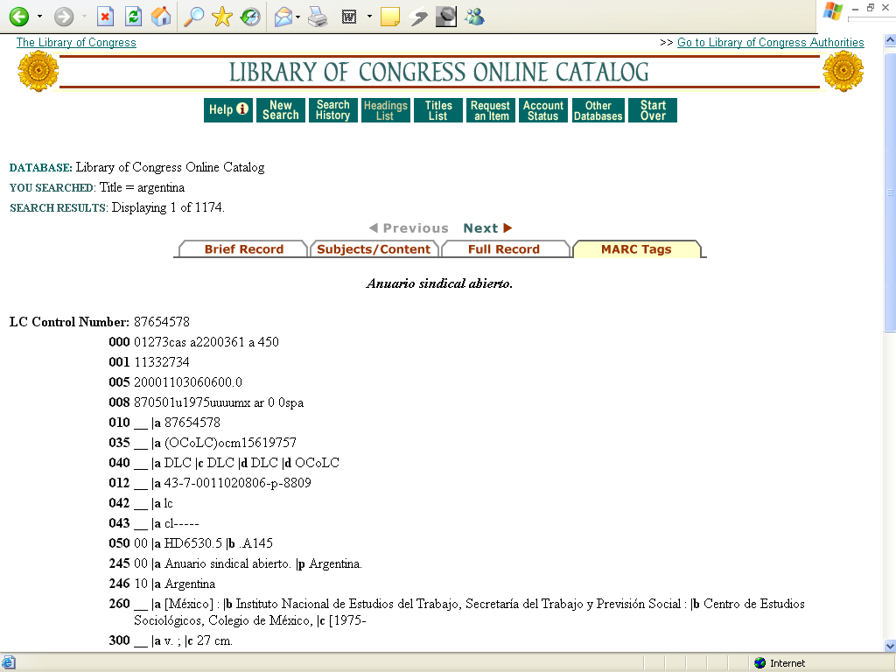

The user could download the record, pressing over Marc-8 (not Unicode), and will obtain:

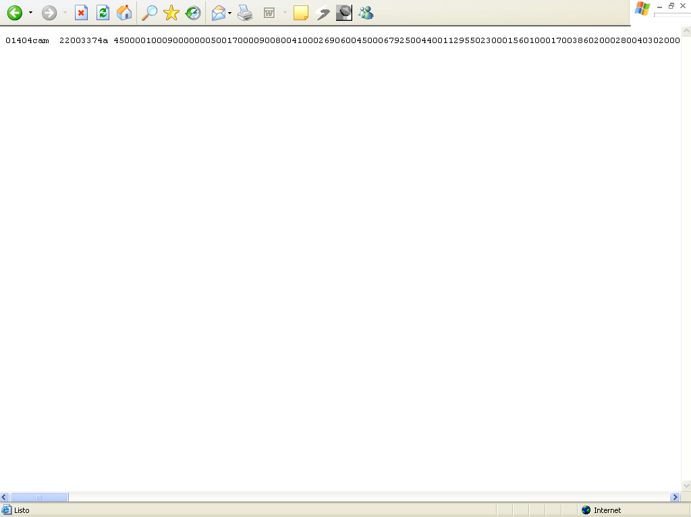

After this, the user could select and copy the content of the window, and put it into MARC import wizard.

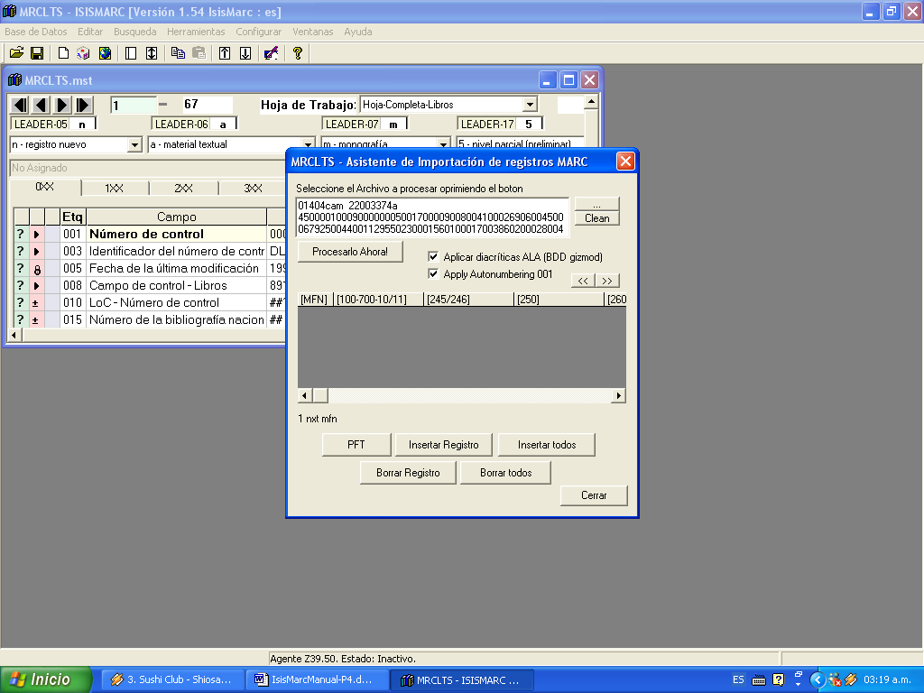

Now the user could press Process It, and the record will be inserted into the temporary database. The way for introducing one or more records is to save the records into a separate file. Some catalogs only offer this posibility. Keep in mind that, for instance, if you select several records from the original catalog, could paste directly into the text-box for direct processing. In this case, the user could press the elipsis button and could choice the file that contains the MARC records.

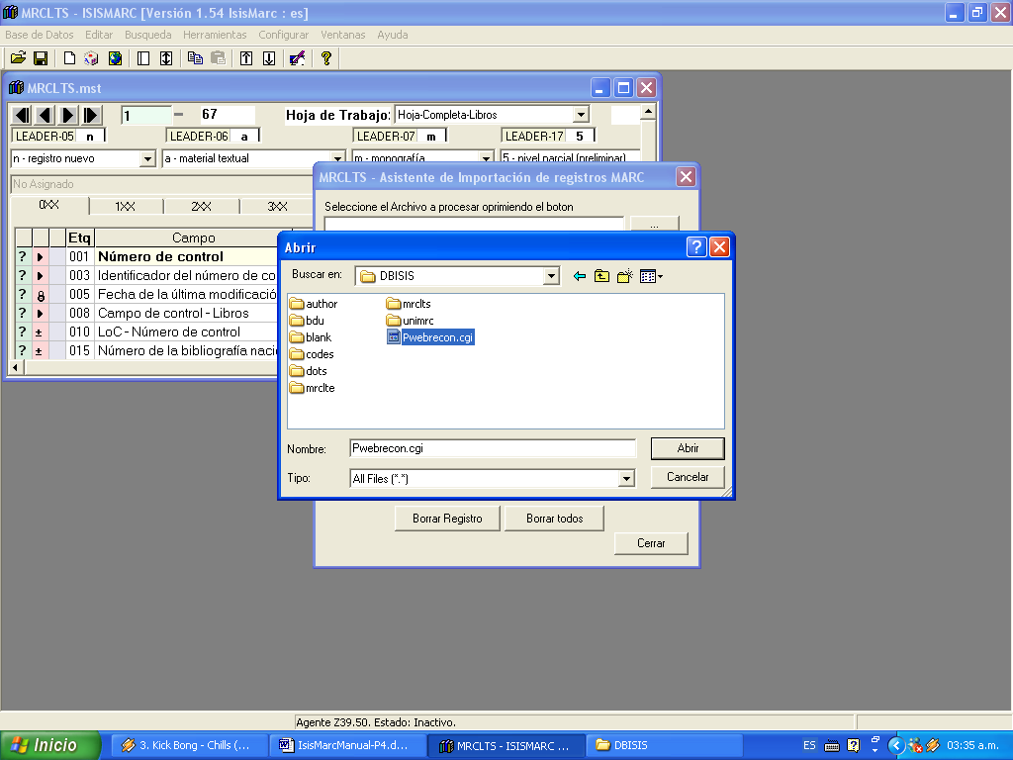

The imported records will appear in the list presenting 100 and 700 (should be configured for next releases considering UNIMARC) fields and title.

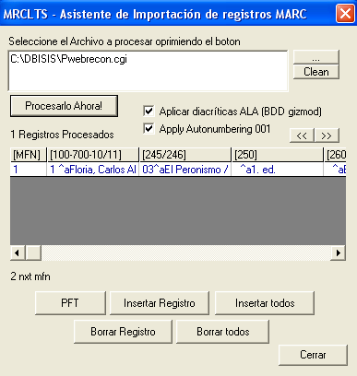

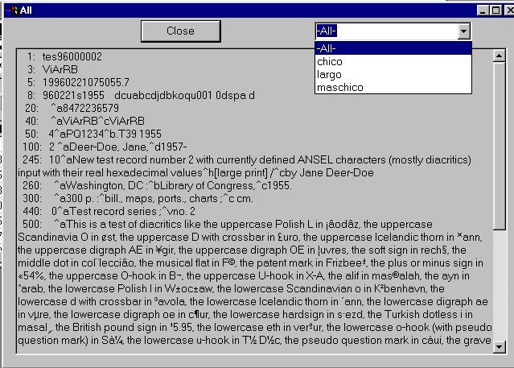
The final purpose of this functionality is to import MARC21 records from external sources to the user’s database. The first step could consist in looking the imported record. This could be done pressing Enter over the selected record, double click or clicking over PFT Button.

This window presents the imported record and the tags that it contains.

Atention: The imported record is not directly transferred to the database that is actually opened. The user must indicate to IsisMarc that wants to transfer this record to the database. All the imported records are stored in a Temporal database called temp that resides in c:\Temp.

Atention II: The user could see how the record will “fit” inside the database using the format combo. All the formats are from the database window that is actually activated.

When the user wants to add a selected record inside the actually opened database, simply must click at the Insert Button. IsisMarc will copy the selected record at bottom of the currently opened (and selected) database. The database that will receive the record is showen in the Title bar of the Import Window:
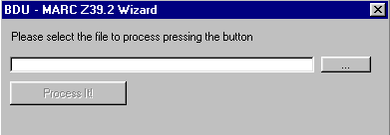

After inserting the record, the inserted record will be showen with a rose background indicating that this record has been added to some database ( Or the same, that has been used).
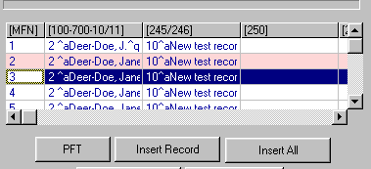

The user could also Insert All the records that are inside the temporal database (in this case all the records will be painted in rose), delete some record or delete all the records in the temporal space (database).

Final Observation: All the functionality of inserting is enabled exactly as the user is typing the copied record. It means that if UPDATE=1 in isismarc.cip the imported record could be searched inmediatly after it was imported. Also the log text and so on will be updated.

- Searching over Z39.50 servers. Defining new servers.

IsisMarc 1.53 has added the YAZ (http://www.indexdata.com) Open Source library. This library adds the functionality to access Z39.50 servers.

This introduces also a question: How to define which Z39.50 servers will be accessed?

IsisMarc 1.53 comes with an Isis Database called servers that defines which servers will be accessed. The user could choice from this database for each search, which servers wish access for completing the query.

The servers database is a common WinIsis database that could be modified in the common ways:
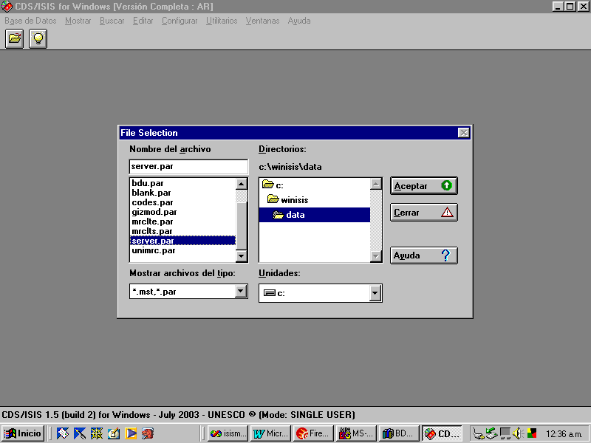

The final user could access to this database and define/delete/add or modify new Z39.50 servers for accessing through IsisMarc:

There are only four fields to complete:
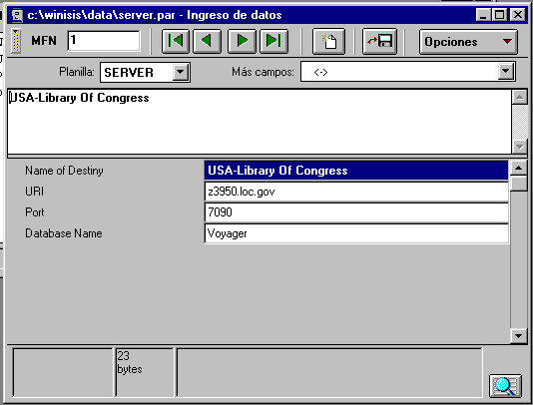

The name of the destiny (This is how it will be referenced inside IsisMarc), the URL to access it, the port and the database name.

IsisMarc comes with 44 servers predefined, mostly from spanish spoken libraries.

How Z39.50 works inside IsisMarc? Z39.50 Agent.

Z39.50 searches could take long time. This is specially true from countries without good Internet conection. The protocol says that the way is:

- Open a session with the server.
- Perform the query.
- Check the number of results.
- Obtain the results.
- Close the session.

Aditionally IsisMarc stores the results in another temporal database for admiting that the user could import this records to the final database, after a process of examination of the record obtained.

For this reasons, IsisMarc 1.5 has added an agent that could make all this process and allows the user to continue working with another tasks inside IsisMarc.

It means that the process of doing a Z39.50 Query is to inform IsisMarc for the search expression, indicating which servers will be accesed, and simply leave it and continue working with another thing until IsisMarc informs that this query has finished and could be accesed.

We could realize that IsisMarc comes with a “person” that makes the Z39.50 work. We inform to this “person” that we need a Z39.50 and he/she will start its works. We could continue editing or adding or searching records using the same IsisMarc interface and when this “person” has finished will inform us that “has nothing more to do”.

We named this person as Z39.50 Agent.

One of the differences in this new IsisMarc version is related to the Status Bar, it seems like this:

This is the indication that the agent “has nothing to do”.

The Z39.50 agent work in time-intervals. It means that checks if has “something pending” for example each 20 seconds. Also it means that when a new query is inserted, the user must wait that agent is activated to attending it.

The time interval could be defined in isismarc.cip however.

How to make a new query?

The query Window could be accesed through the File menu:

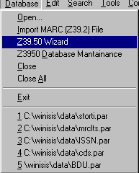
This is the way to access to the Z39.50 Wizard.
The window that appears looks like:

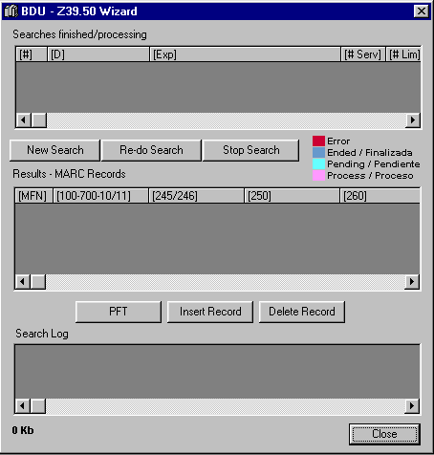
1
2
3
4
5
Let’s analize every part of the window.

The part that is signaled with 1 is related to the searches that have been done or are in Process. If you want to make a new search simply click over New Search.

If you want to perform the same last query, could use Re-do search.
If you want to Stop the current search, press over Stop Search.

Let’s see part signaled with 2. This are the states representation. In rose it means that the query is in process. In red that the query has obtained some error code, in Cyan that is in queue and in blue that is finished.
In cyan it’s indicating that the Z39.50 agent has not attending it yet. Could be attending some other query or will be attended next time (see time periods) the agent is activated.

The part signaled with 3 corresponds to the records area. Here will be presented the records obtained for each search. It means that when the user clicks over part 1, all the records that this search has obtained, will be presented in area 3.

As with the MARC import assistant, the user could select a record and insert into the database window. Remeber that all the records that comes from Z39.50 goes to a temporal database (that, inclusive, is no the same that used by the Import MARC assistant). For inserting a Record, the user could press Insert Button and the record will be painted in rose indicating that was “used”.

Log Tool. Area 4.

Some Z39.50 servers could admit some kinds of queries and some others not. IsisMarc 1.5 comes with a predefined Bib-1 sets trying to use the more commons of its. However some specialized queries (that uses some Bib-1 attributes) could be not admitted in some servers.

Another kind of problem could be that simply the connection could not be reached between IsisMarc and the Z39.50 server. This kind of problem could be generated because bad URL definition, bad database definition or simply that the Z39.50 server has been shuted down, the database name has changed, or the service has been converted to a “password mode”.

The very different nature of the problems has determined that a Log information is necesary. For example with the purpose of evaluating how many servers could be reached and ansewered from my original choice, or simply how many has records for sending me.

The area 4 informs all the tasks that have been done by the agent in the process of the query. It means that when the agent tries to connect to the server, it stores a log from this connection, when sends the query, stores the query and so on.

This functionality allows the user to analyze the entire result from a query. However clicking over area 1, area 4 will be refreshed showing the log for the selected query. The log database is an Isis database that is stored in C:\Temp.

Matter of size. Area 5.

The final user could choice how many results from the server wish to obtain and store locally. With a constant use this way of working could be very expensive in terms of disk space. The area 5 is presenting how much space the temporary Z39.50 databases are using from this machine. It includes the records database and the log.
Making a new Query. PQN and Isis Search Language.

When the user generates a new search this window is opened:
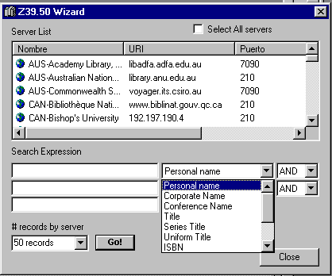

The first list presents all the servers that are included in servers database, that we have seen how to touch.

We could choice one or several (or all, clicking over Select all servers) Z39.50 servers. After that we could add a search expression qualifying it with the options referring to the field/tag. Also we could add a logical operator for all the expressions. Isismarc will generate the appropiate PQN Search expression to be sended to the Z3950 Servers and will obtain the results and the diagnostics for this particular Search.

We could choice also how many records from each server we want. Finally we press button Go for doing or Close to Cancel.

Putting all together.

Our first step will be input a new search. We have selected all the servers and put a “complex” expression:

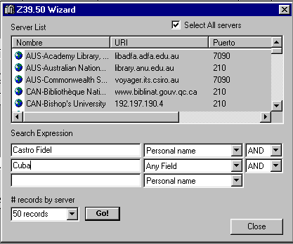
After pressing the Go! Button this window desapears and the Z39.50 wizard looks like this:
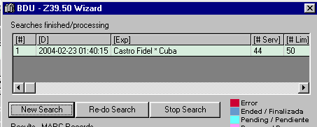

As we can see, the search is inserted in Pending state, waiting for the agent. Also the search expression is converted to a “Isis comprensible” expression. This is not the expression that will be sent to server, this could be seen moving in this area to the right.

The next step is simply to close the Window and continue working with some another thing. The agent will comunicate us its work through the state bar.

Atention: For security reasons is highly recommended to Close the window after inserting a new query and opening it only when the agent tells that is doing nothing.

Few moments after the Agent is informing that the search is attended. The agent will be informing the progress of the search, it means how many servers have been visited.
When the search finishes. The agent will inform that is updating I/F from logs and records. After that will inform that is “doing nothing”. We could re open the window and seeing the results.
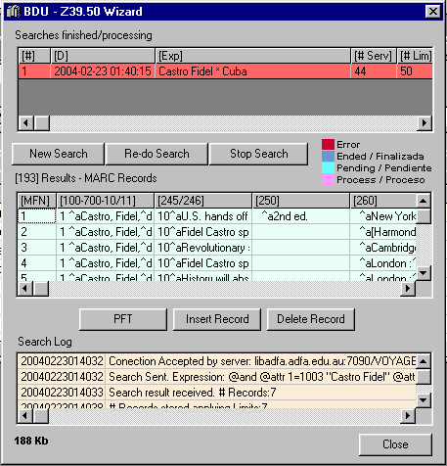

As we can see, the search has obtained 193 results.
The search has finished with error state.

Atention: All the searches that in some action contains an error, will be saved in this state indicating that some servers could not respond or have a search error.

We now could see the records obtained using the database currently opened formats or simply to see all the record.

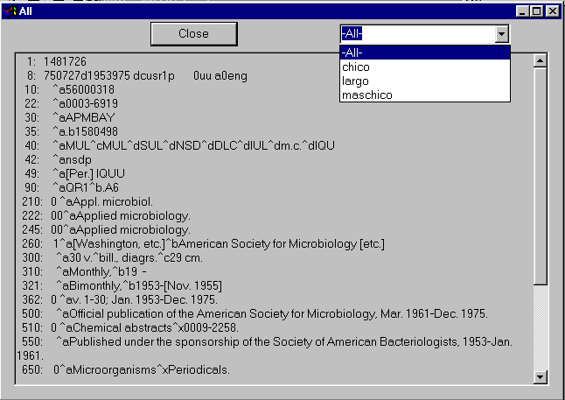
Selecting from the list box, we could see “how will be seen” this record inside the database.

- Deleting and mantaining Z39.50 temporary databases

If you are refreshing the Z39.50 databases and the Agent is doing searches, the indexes could be broken. Also if you want to erase some searches or delete all the previous searches you will have an option for mantaining the databases:

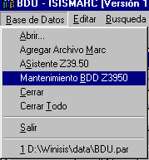
This option will warn about the Z39.50 agent will be disabled until the operation will finish. After that it opens the following window:
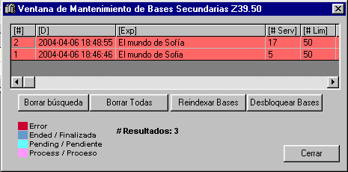

Using the first button you could delete the results/log from the selected search. Using the second you could delete all the searches log/result. The third button is used for reindexing all the temporary databases’s index. The fourth is used to unlock the temporary databases if any problem has happen. The recommended procedure is to unlock the databases and after that reindex the temporary databases.

IsisMarc will use C:\Temp folder for storing Import and Z39.50 databases. If you erase the content of the folder, IsisMarc will re create every database but all the records, searches and logs will be lost.

- Deleting all the records from the actual database.

Using the following procedure you will delete all the content of the actual database. It will present two confirmation steps, after them the actual database will be erased.

- Added parameters to isismarc.cip

During the new install process made with Open Source’s InnoSetup, IsisMarc install process will ask

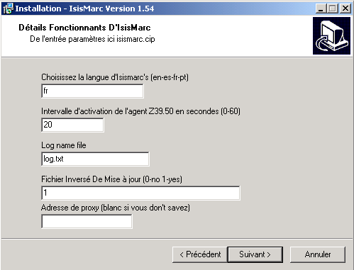

- Language (could be actually en-English / es- Spanish / fr-French / pt –Potuguese)
- Intervalz parameter. We’ll explain more downstair.
- Log name file
- Update Inverted File (isismarc.cip UPDATE=0 or UPDATE=1)
- Proxy for Z39.50 connection.

For a parameters that will be saved to isismarc.cip. After installing you can however, change this simply editing isismarc.cip.

As it’s explained in the setup screen, the INTERVALZ parameter defines which is the period that the Z39.50 agent is waken up. If it’s defined to 0, simply the Z39.50 features will be disabled. The valid period is between 20 and 60 seconds.

If you have a proxy for doing Internet connections, you can also store the IP address for detecting and making Z39.50 through this IP address.

All of this options could be post-install changed simply editing isismarc.cip file

From version 1.542 in advance, will consider isisuc and isisac.tab for inverted file updating. As WinIsis this files should be stored in /Winisis/IsisMarc/Menu folder.

New parameters added to isismarc.cip

Parameter | Posible Values | Explanation
INTERVALZ | <seconds> | Interval in seconds for activating Z39.50 agent.
PROXY | <IP address> | IP address for using proxy in Z39.50 agent. Configuration used by YAZ library.
AUTOPREFIX | <text> | Used for 001 field. If you want to auto-complete 001 field with a patron text you could use this parameter. For example:  AUTOPREFIX=PHYS-
AUTONUMBER | <filename> | Used for 001 field. If you want that IsisMarc completes automatically with a number, you could create a text file, simply inserting the number and specify in this parameter the name of the file. IsisMarc will open this file, read the number put into the records, and add 1 to the number and store into the file.  AUTOPREFIX=id.lck
8 | <string> | compatible WinIsis repeteable field was added. It serves for defining the special  sequence of characters that defines a repeteable field/subfield. It was reported that  some records includes % as data inside a field. For avoiding this problem could be added  8=%% for example in isismarc.cip  Using this parameter only when the user types two % it will be interpreted as a repeteable  occurrence for the field/subfield.

New parameters added to isismarc2.cip

Parameter | Posible Values | Explanation
LEADER5 | Char | Auto values por every new record for a particular database.
LEADER6 | Char | Auto values por every new record for a particular database.
LEADER7 | Char | Auto values por every new record for a particular database.
LEADER17 | Char | Auto values por every new record for a particular database.
LEADER18 | Char | Auto values por every new record for a particular database.
LASTEXPORTDATE | <ISO Date> | Will store the last ISO date time that the database was exported. It will be used for generating Diff packages between export procedures or sending the information to an ILS software.
LASTEXPORTTAG | <tag> | Will store the last tag used for comparing date/time and in this way obtain the modified records. For MARC21 and common distro databases should be used 005 tag, but could depend of formats and particular configuration.

- Which databases are included inside this distribution?

In this distribution we’ve included the same older databases included with IsisMarc and added two databases that have some added work. BDU database is the default opened database is an extract of 100 record of Argentina’s MARC21 Union catalog administered by Education Ministry. It has a lot of entry worksheets each one oriented to some differents material types. This work has been done by Cuyo’s University librarians. The complete isismarc folder (inside BDU data) could be copied to another database for using this work. However mrclte, mrclts, unimrc and author databases are included in this package.

- Uninstall process.

The software could be uninstalled through normal windows Control Panel, Add/Remove Programs. The WinIsis folder, .par files and all DBISIS folder will remain in computer. All the databases will remain inclusive if you install IsisMarc (1.5) software again. The actual process to delete an entire database and force to be reinstalled is manually delete from DBISIS folder.

- MARC21 Export Records.

From IsisMarc 1.54 is there a new feature that admits to export the entire or some part from the database as MARC21 (ISO2709) file. This feature generates a .mrc file corresponding to the filtered data and also (adding a ZIP embedded library) will generate automatically a ZIP file corresponding to the compressed .mrc file.

This feature is accesed through the following option from main Menu:

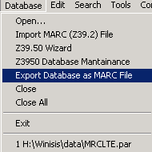

And will present the following window:

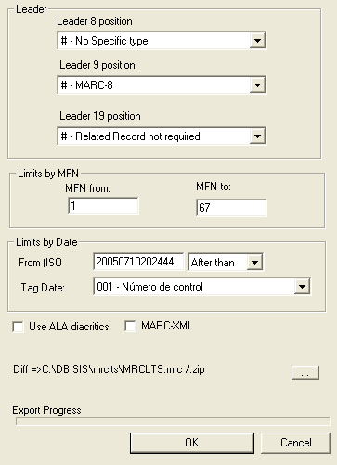

This window admits to enter the leader values for position 8,9, and 19 for every MARC21 record that will be exported. Also it admits to limit the range of records that will be exported inserting MFN from and MFN to. This two parameters could be freely combined.

Every new export alters LASTEXPORTDATE parameter in isismarc2.cip (if isn’t present will be created). This feature admits to create Diffs from exports, for example to export only affected records within certain period of time. Normally this parameter will be used comparing the date with 005 field that is auto-completed (depends from input sheet, could be seen in Book worksheet examples), if you want to do some export based on some field: IsisMarc lets you choose which field will be used for comparing and storing date time values.

The “…” button let you choose where the data file will be stored in filesystem disk. ALA diacritics check will replace special characters with ALA diacritics that reside in GIZMOD database. This database that could be used also in Import feature, could be opened and modified using WinIsis.

If you check MARC-XML will obtain an XML file compliant with SLIM schema

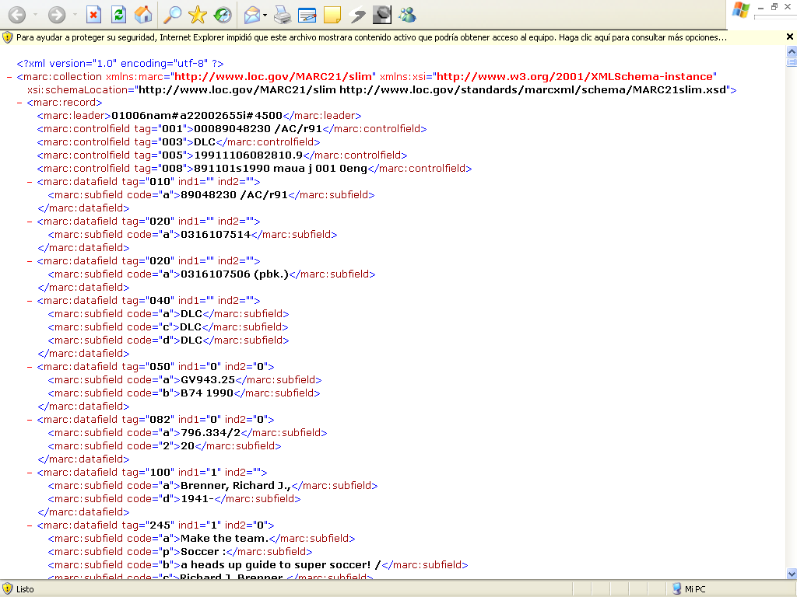

- Auto-select worksheet.

From IsisMarc 1.542 in advance a new feature is added for making relations between the data that is stored in the record and the worksheet that should be used for entering the data. It ‘s most used when the user has different material support inside the same database. In this cases, the user has have to select the appropiate worksheet to see the particular fields.

IsisMarc 1.542 adds a new field to FMT21 (tag 153 in FMT21.mst) that will store an Isis Format condition to use one particular worksheet. Also FMT21 Editor will include the input field for this data.

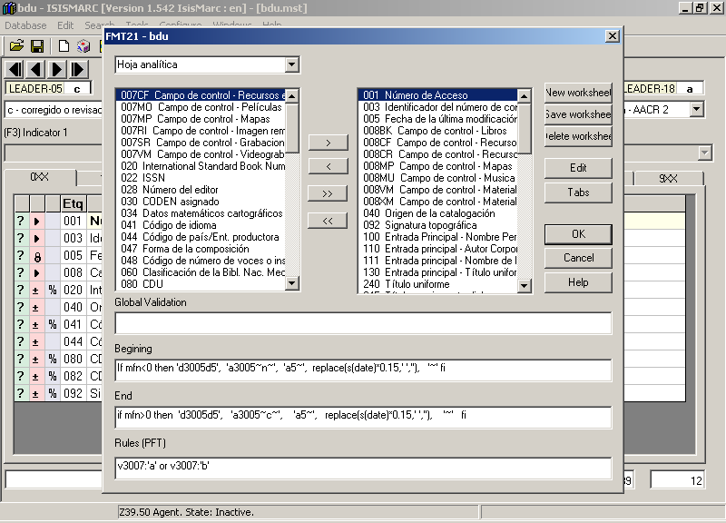

The last input text will admit to store the condition for presenting this worksheet. In this case, this analitic worksheet will be used when the leader’s 7 position takes ‘a’or ‘b’ value. The user could create freely as many conditions as wanted.

Should be considered that IsisMarc will use the WKST parameter defined in isismarc2.cip when opens a database, but will loop inside all worksheets to test the conditions that the user have stored. If the default worksheet has a condition that evaluates to false considering the values stored in the record, and no other worksheet could be evaluated to true value, IsisMarc will present the record in this way:
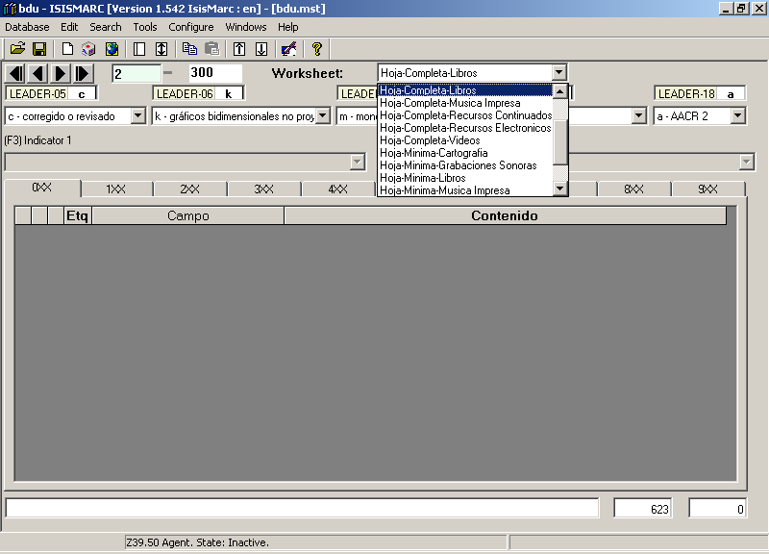

It’s important to say is there no information lost. Simply IsisMarc could not autoselect the worksheet to be used to present this record. The data for the record could be presented selecting the list box for the worksheet, forcing IsisMarc to use a particular worksheet or to select all fields to check the problem.

A final comment is referred to study the conditions to store in this behaviour to maximize the confort in cataloging and prevent the above error.

The correct behaviour (using the appropiate conditions) should be the following (This is only an example).

Complete Book Worksheet. Condition (tag 153 of FMT21): v3007<>’a’ and v3007<>’b’
Analitics Worksheet. Condition (tag 153 of FMT21): v3007=’a’ or v3007=’b’

When the user goes to MFN 1:

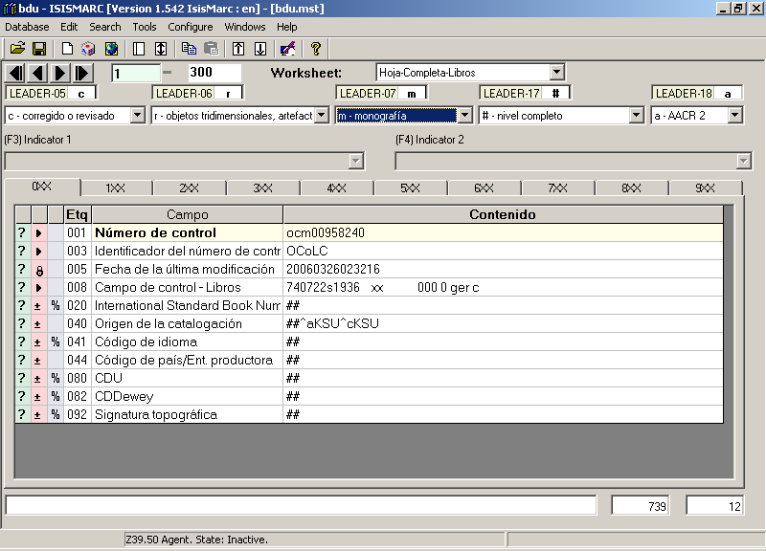

IsisMarc will autoselect Complete Book worksheet because v3007<>’a’ and v3007<>’b’
If the user changes the 7 position for the leader, and selects ‘a’ (part of a colection).

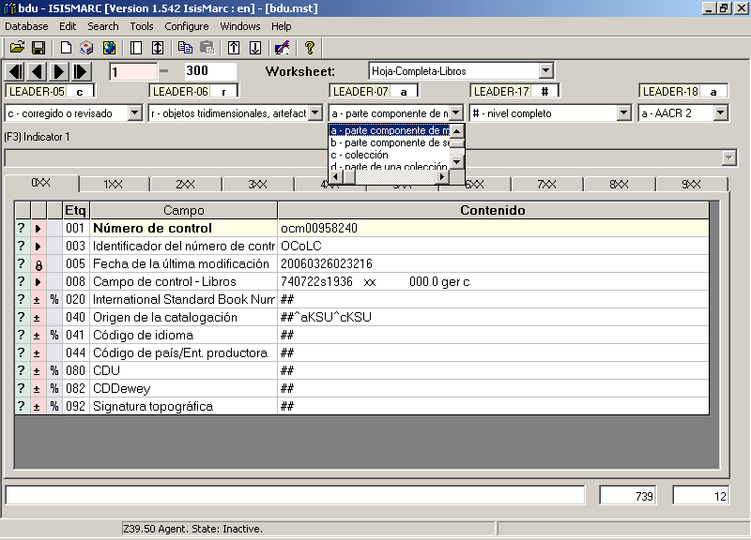

And saves the record, IsisMarc will evaluate if an appropiate worksheet should be used with this new value for the record, and found analitics worksheet. Because of this, after saving, IsisMarc will auto-change the worksheet, showing Analitics worksheet.

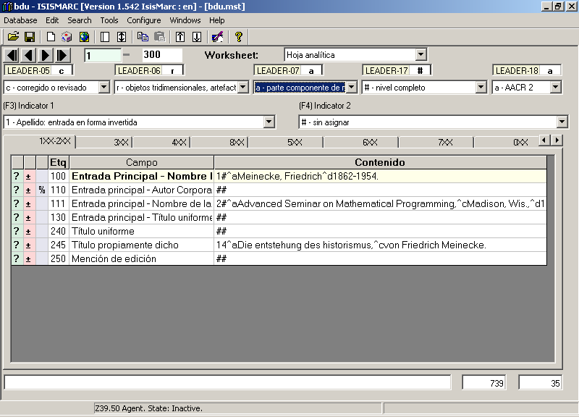

By a limitation of Isis_DLL, errors in format language for building the expression for FMT21 conditions will not be trapped. Try to validate the Isis Format expression before to store it in IsisMarc. External formats or referrences to PFT21 database (for example @complete) are not considered in version 1.542.

It’s important also to say that previous FMT21databases could be used, no change is needed in production databases. If the user adds FMT21 rules, simply IsisMarc will store it in 153 field in FMT21 database.

- Contextual Copy of Records.

From 1.542 version in advance a new feature is added when you try to copy a record inside the same database or between databases. This feature opens a new window offering the option to create a new record or overwrite an existing one:

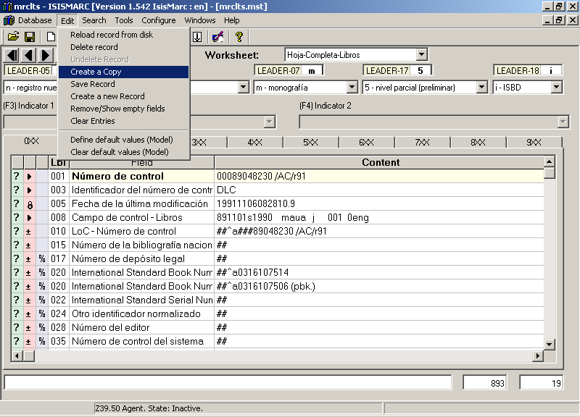

After this operation the following window will be shown:

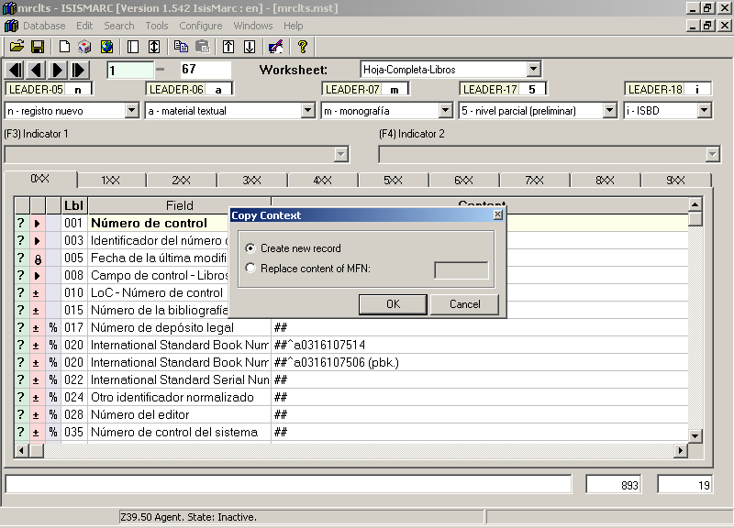

If you create a new record, this is the normal behaviour of Isismarc pre 1.542.
If you overwrite a record, let’s say record 10:

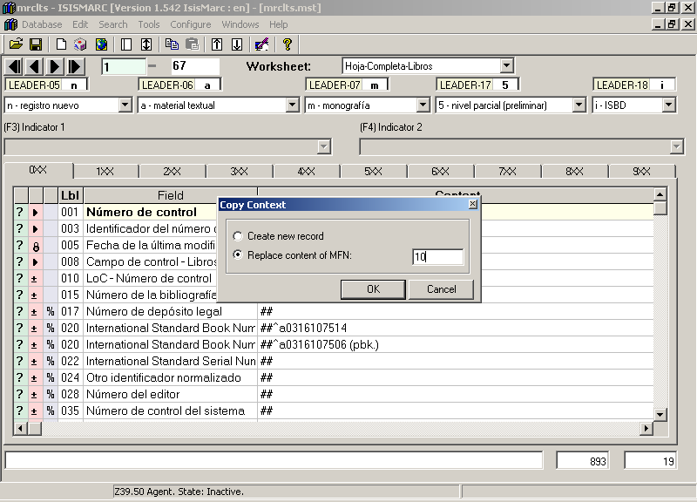

The MFN 10, will be shown, and the previous content was replaced by the original record that was copied:

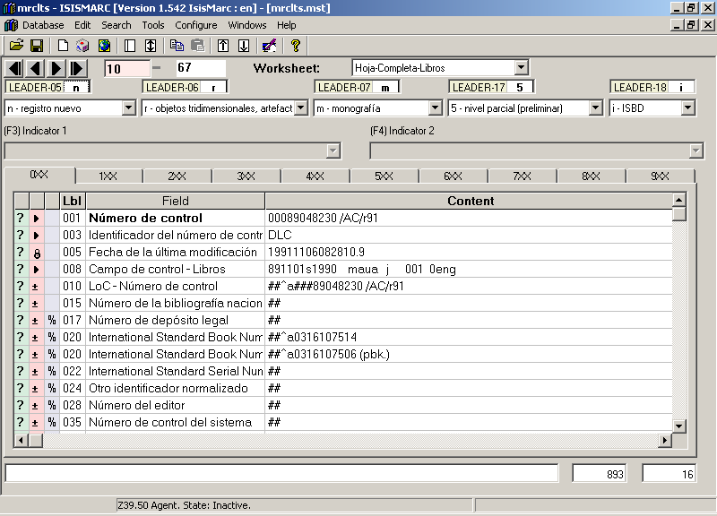

As could be seen, if you want to discard the previous operation, simply do not save this record and inform to IsisMarc to discard the changes.

The same behaviour is expected for “between databases” record copy.

Development Group. Credits.

- Argentine’s Ministry Of Education. University Information System (UIS)
http://www.siu.edu.ar

Contact:
Emiliano Marmonti
emarmonti@siu.edu.ar

- Ing.Alexandra Fernández (Uruguay).
Alexandra was the original developer. Actually she actively help us for trapping errors and to build new functionality.

- Ing.Ernesto Spinak (Uruguay).
Original idea and design.
spinaker@adinet.com.uy

Main tester and contributing group.

- Argentine’s Cuyo National University. Integrated Documentation System (IDS)
http://sid.uncu.edu.ar

Paula Ceriotto
Patricia M.Testa

Cataloging and MARC21’s Unit.

Software Components Credits

YAZ Library
Used for Z39.50 access
License: http://www.indexdata.dk/licensing/yaz/
http://www.indexdata.com

Inno Setup Installer
Used for the install package, translations
License: http://www.jrsoftware.org/files/is/license.txt
http://www.jrsoftware.org/isinfo.php

